6-7)

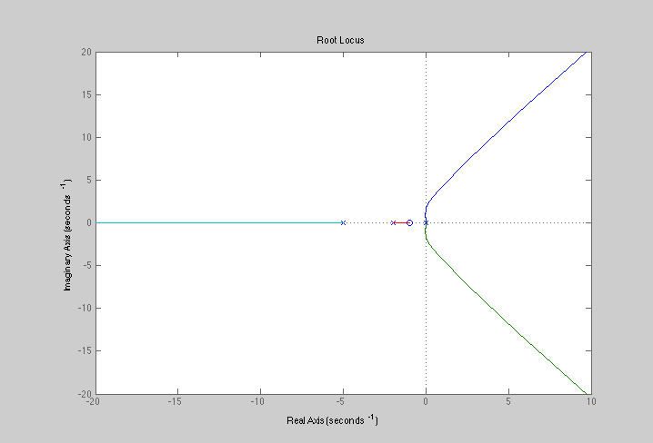

6-11)

%%

%#11

clc

clear

s=tf('s');

sys=(2\*(s+1))/(s\*(s^2+2\*s+6));

H=1/(s+1);

rlocus(sys,H)

Poles at 0, -1+- j2.24

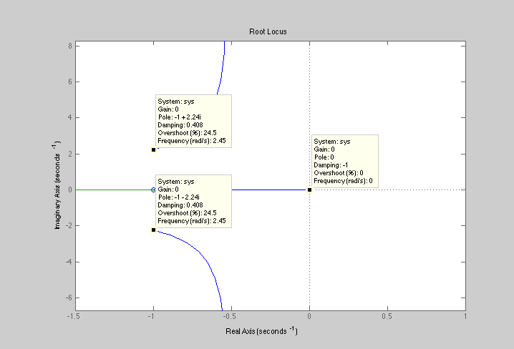

Problem 1)

%%

%#b

clc

clear

k=6.8761763779;

s=tf('s');

sys=(k\*(s+10))/(s^4+7\*s^3+20\*s^2+(24+k)\*s+10\*k)

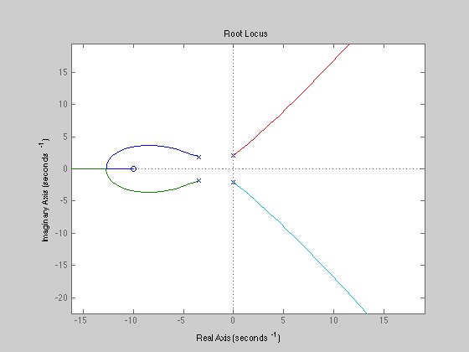rlocus(sys)

step

pole(sys)

ans =

-3.5000 + 1.8273i

-3.5000 - 1.8273i

0.0000 + 2.1002i

0.0000 - 2.1002i

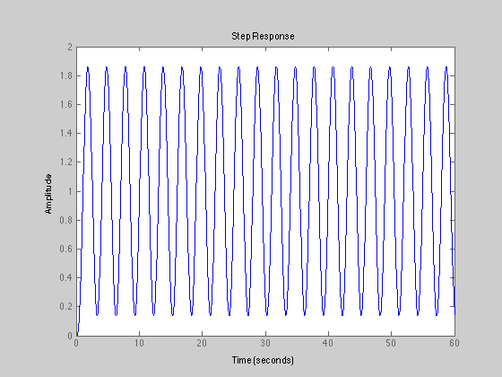

Problem 2)

clc

clear

s=tf('s');

sys=((s\*573))/(s^2+33.14\*s+573)

rlocus(sys)

%step(sys)

pole(sys)

